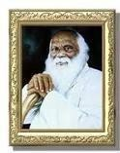

Rayat Shikshan Sanstha’s
Karmaveer Bhaurao Patil Polytechnic, Satara

Micro-Project Report
On

“Color Picker Tool”
Presented By
ROLL NO. | NAME OF THE STUDENT
126 | Mo Abrar Shoukat Shaikh

Program: Diploma in Computer Engineering

Class: Third Year (Semester VI)

Course: Client-Side Scripting (Subject Code: 316005)

Guided By
Mr. Shinde A. D.
Computer Engineering Department

[2025-26]

Rayat Shikshan Sanstha’s

Karmaveer Bhaurao Patil Polytechnic, Satara

CERTIFICATE

This is to certify that Mr Mo Abrar Shoukat Shaikh of Third Year (Semester VI) have successfully completed the Micro-Project work entitled “Color Picker Tool” in the Client-Side Scripting (316005) of Program Diploma in Computer Engineering of Maharashtra State of Technical Education, Mumbai, Maharashtra State.

Mr. Shinde A. D. Mr. Ghorpade B. S. Mr. Kadam B. V. Guide Head of Department I/C Principal

Date: Place:

UNDERTAKING

I, Mo Abrar Shoukat Shaikh, Enrollment Number 24210940248, studying in 3rd Year, Computer Engineering Branch, VI Semester 2025-2026 Year, hereby undertake that I will preserve the micro-project and its report in my custody until the completion of my program. I assure that I will produce the same without fail whenever I am asked to do so.

Date:

Place:

Signature of Student:

Annexure – I A Part A – Plan Micro-Project Proposal
Color Picker Tool
- Brief Introduction:

The Color Picker Tool is a web-based application that allows users to select and preview colors in real-time. It supports HEX and RGB formats and provides features like copy-to-clipboard and color history tracking. This project is important for web designers and developers to quickly choose and manage colors efficiently.

- Aim of the Micro-Project:

This micro-project aims at developing an interactive color selection tool using JavaScript that improves user experience and simplifies color management.

a. To implement real-time color selection
b. To display HEX and RGB values dynamically
c. To provide clipboard and history features
- Action Plan

Sr.  No. | Details of Activity | Planned Start date | Planned Finish date | Name of Responsible Team Members
1. | Requirement study & planning  (guided by Mr. Shinde A.D.)
2. | Design of interface & modules.
3. | HTML structure development
4. | CSS styling & responsiveness
5. | JavaScript implementation
6. | Integration of components
7. | Testing & validation
8. | Documentation & submission

- Resources Required and Used

Sr.  No. | Name of resource / material | Specification | Quantity | Remarks
1 | Hardware | Computer/ Laptop: Minimum i3/i5, 4GB RAM | 1
2 | Software | Platform - Windows 10,11.  Software tools – VS Code, Browser, GitHub. MS Word. | 1

*********

CONTENTS

Chapter |  |  | Contents | Page No.
1. |  |  | Introduction | 1-5
2. |  |  | Diagrams
 | 2.1 |  | Flowchart | 5-10
 | 2.2 |  | Architecture Diagram | 11-15
 | 2.3 |  | Block Diagram | 16-20
 | 2.4 |  | Class Diagram | 21-25
3. |  |  | Source Code | 25-30
4. |  |  | Output (Screenshot) | 30-35
5. |  |  | Conclusion | 35-40
6. |  |  | References | 45-50

CHAPTER 1: INTRODUCTION

The Color Picker Tool is designed to provide an easy and efficient way to select colors for web applications. It allows users to pick colors using a color input tool and view them in HEX and RGB formats. The tool also includes features like real-time preview, clipboard copy, and color history.
This project demonstrates the use of JavaScript for DOM manipulation, event handling, and real-time UI updates.

CHAPTER 2: DIAGRAMS

  - Flowchart:

Start

Select Color

Update Preview

Display HEX & RGB

Store in History

End

  - Architecture Diagram:

UI Layer

Browser
Logical Layer

Browser

  - Block Diagram.

Processing
[JavaScript]
Output
[Preview + Value]
Input
[Color Picker]

  - Class Diagram:

History Manager
Ui Controller
Color Manager

CHAPTER 3: SOURCE CODE

<!DOCTYPE html>
<html lang="en">
<head>
<meta charset="UTF-8">
<meta name="viewport" content="width=device-width, initial-scale=1.0">
<title>Color Picker Tool</title>
<style>
Body
{
font-family: Arial, sans-serif;
background: #f4f4f4;
display: flex;
justify-content: center;
padding: 20px;
}

.container
{
background: #fff;
padding: 20px;
border-radius: 12px;
width: 320px;
box-shadow: 0 5px 15px rgba(0,0,0,0.1);
}

h2
{
text-align: center;
}

.preview
{
height: 100px;
border-radius: 10px;
margin: 15px 0;
border: 1px solid #ccc;
}

input, button
{
width: 100%;
padding: 8px;
margin: 6px 0;
border-radius: 8px;
border: 1px solid #ccc;
}

button
{
cursor: pointer;
background: #333;
color: white;
}

.history
{
display: flex;
flex-wrap: wrap;
gap: 5px;
margin-top: 10px;
}

.swatch
{
width: 25px;
height: 25px;
border-radius: 5px;
cursor: pointer;
border: 1px solid #ddd;
}

.error

{
color: red;
font-size: 12px;
}

.toast {
position: fixed;
bottom: 20px;
right: 20px;
background: black;
color: white;
padding: 8px 12px;
border-radius: 6px;
display: none;
}

</style>
</head>

<body>

<div class="container">
<h2>Color Picker Tool</h2>

<!-- Color Input -->

<input type="color" id="colorPicker">

<!-- Preview -->

<div class="preview" id="preview"></div>

<!-- HEX -->

<input type="text" id="hexInput" placeholder="#FFFFFF">
<button onclick="copyText('hexInput')">Copy HEX</button>

<!-- RGB -->

<input type="text" id="rgbInput" placeholder="rgb(255,255,255)">
<button onclick="copyText('rgbInput')">Copy RGB</button>

<div class="error" id="error"></div>

<!-- History -->

<div class="history" id="history"></div>
<button onclick="clearHistory()">Clear History</button>
</div>

<div class="toast" id="toast">Copied!</div>

<script>
const picker = document.getElementById("colorPicker");
const preview = document.getElementById("preview");
const hexInput = document.getElementById("hexInput");
const rgbInput = document.getElementById("rgbInput");
const error = document.getElementById("error");
const historyDiv = document.getElementById("history");

let history = [];

/* HEX → RGB */

function hexToRgb(hex) {
hex = hex.replace("#", "");
if (hex.length === 3) {
hex = hex.split('').map(x => x + x).join('');
}

const bigint = parseInt(hex, 16);
if (isNaN(bigint)) return null;

return {
r: (bigint >> 16) & 255,
g: (bigint >> 8) & 255,
b: bigint & 255
};
}

/* RGB → HEX */

function rgbToHex(r, g, b) {
return "#" + [r, g, b]
.map(x => x.toString(16).padStart(2, '0'))
.join('')
.toUpperCase();
}

/* Update UI */

function updateColor(hex) {
const rgb = hexToRgb(hex);
if (!rgb) return;

const rgbStr = `rgb(${rgb.r}, ${rgb.g}, ${rgb.b})`;

preview.style.background = hex;
hexInput.value = hex.toUpperCase();
rgbInput.value = rgbStr;

addToHistory(hex);
}

/* Picker Event */

picker.addEventListener("input", e => {
updateColor(e.target.value);
});

/* HEX Manual Input */

hexInput.addEventListener("input", () => {
let val = hexInput.value.trim();

if (!val.startsWith("#")) val = "#" + val;

if (/^#([0-9A-F]{3}|[0-9A-F]{6})$/i.test(val)) {
error.textContent = "";
updateColor(val);
} else {
error.textContent = "Invalid HEX format";
}
});

/* RGB Manual Input */

rgbInput.addEventListener("input", () => {
const match = rgbInput.value.match(/\d+/g);

if (!match || match.length !== 3) {
error.textContent = "Invalid RGB format";
return;
}

let [r, g, b] = match.map(Number);

if (r > 255 || g > 255 || b > 255 || r < 0 || g < 0 || b < 0) {
error.textContent = "RGB range: 0–255";
return;
}

error.textContent = "";

const hex = rgbToHex(r, g, b);
updateColor(hex);
});

/* Copy */

function copyText(id) {
const text = document.getElementById(id).value;

if (!navigator.clipboard) {
alert("Clipboard not supported");
return;
}

navigator.clipboard.writeText(text)
.then(() => showToast())
.catch(() => alert("Copy failed"));
}

/* Toast */

function showToast() {
const toast = document.getElementById("toast");
toast.style.display = "block";
setTimeout(() => toast.style.display = "none", 1500);
}

/* History */

function addToHistory(color) {
if (history.includes(color)) return;

history.unshift(color);
if (history.length > 20) history.pop();

renderHistory();
}

function renderHistory() {
historyDiv.innerHTML = "";
history.forEach(color => {
const swatch = document.createElement("div");
swatch.className = "swatch";
swatch.style.background = color;
swatch.onclick = () => updateColor(color);
historyDiv.appendChild(swatch);
});
}

function clearHistory() {
history = [];
renderHistory();
}

/* Default Load */

updateColor("#000000");
</script>

</body>
</html>

CHAPTER 4: OUTPUT (SCREENSHOT)

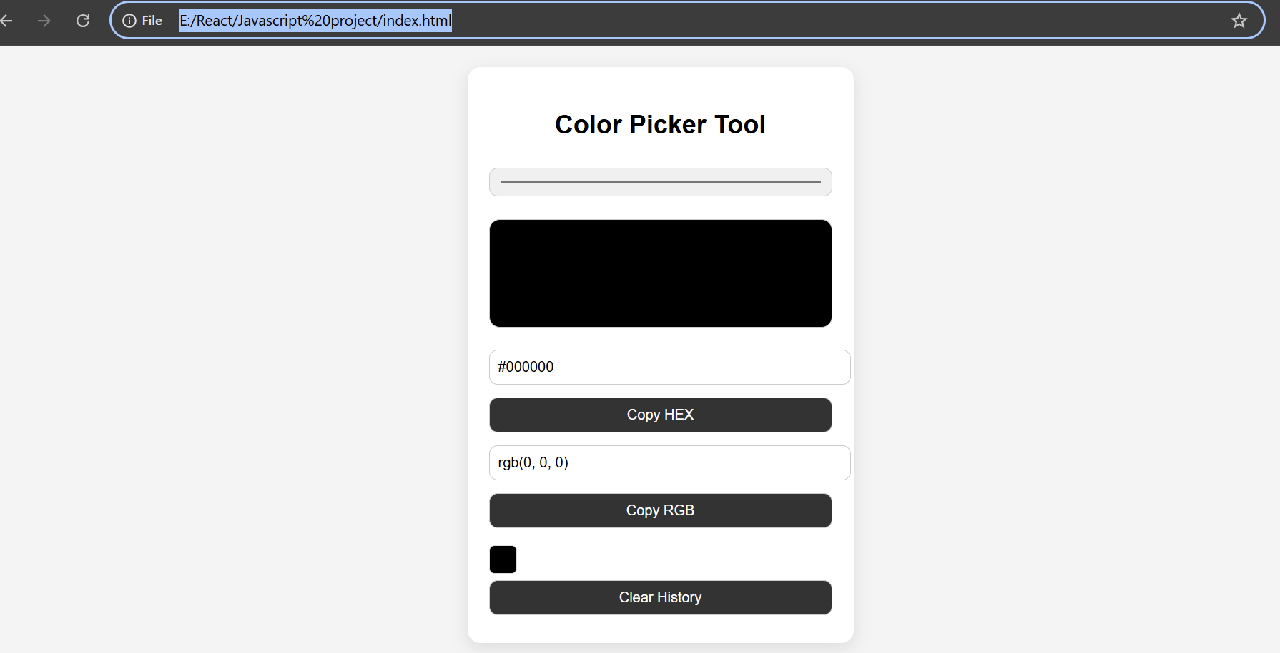

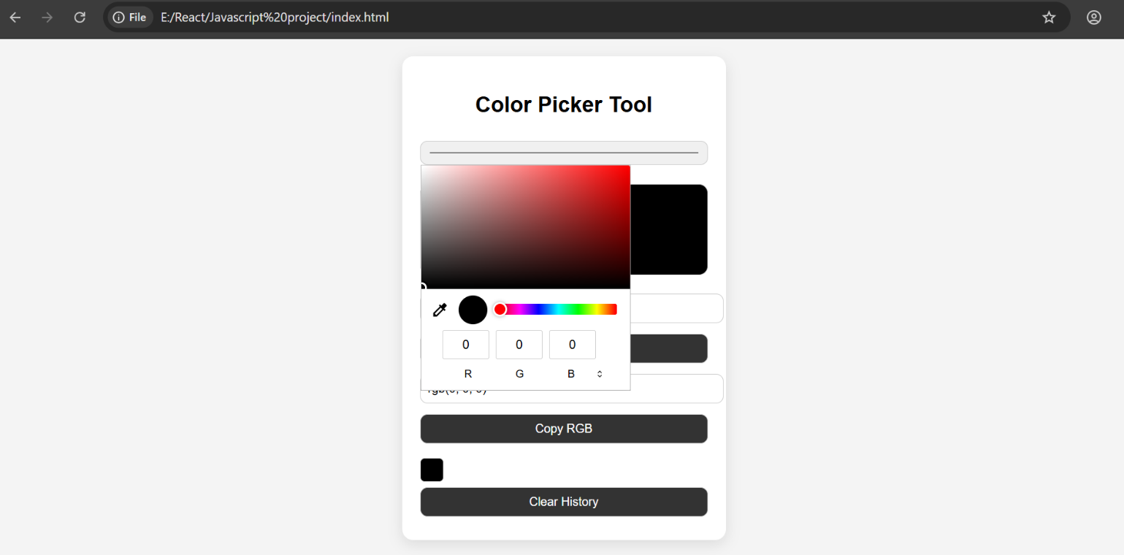

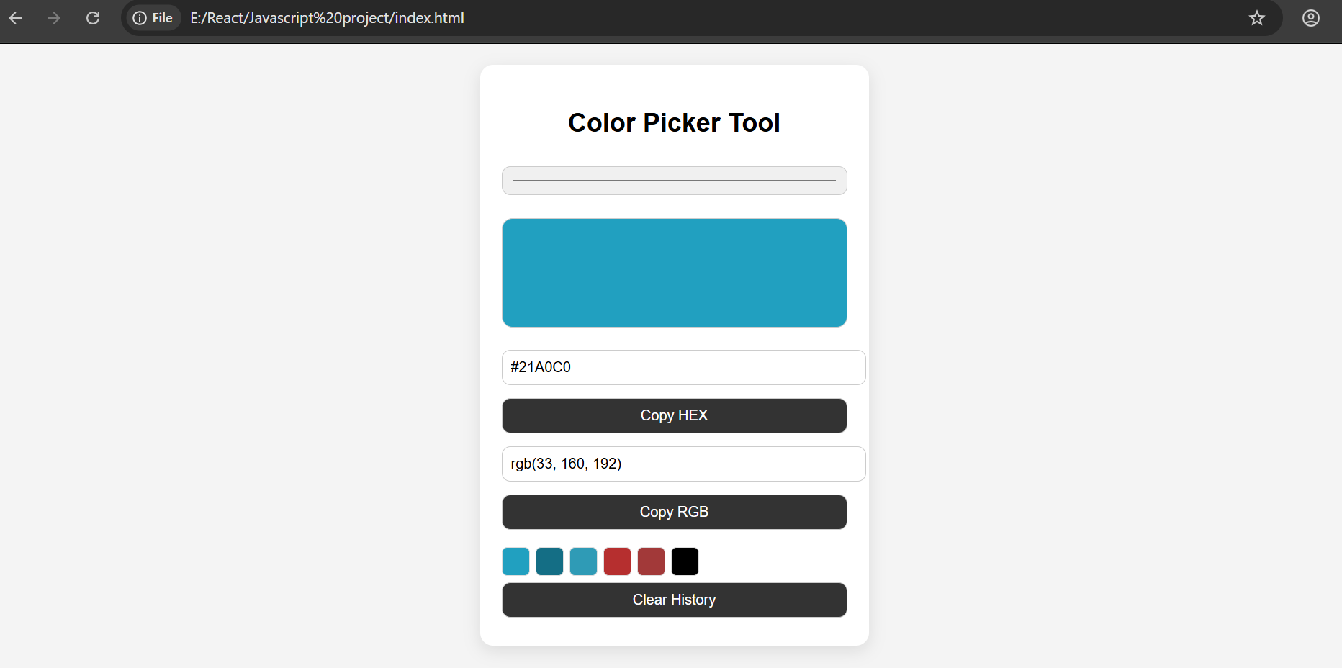

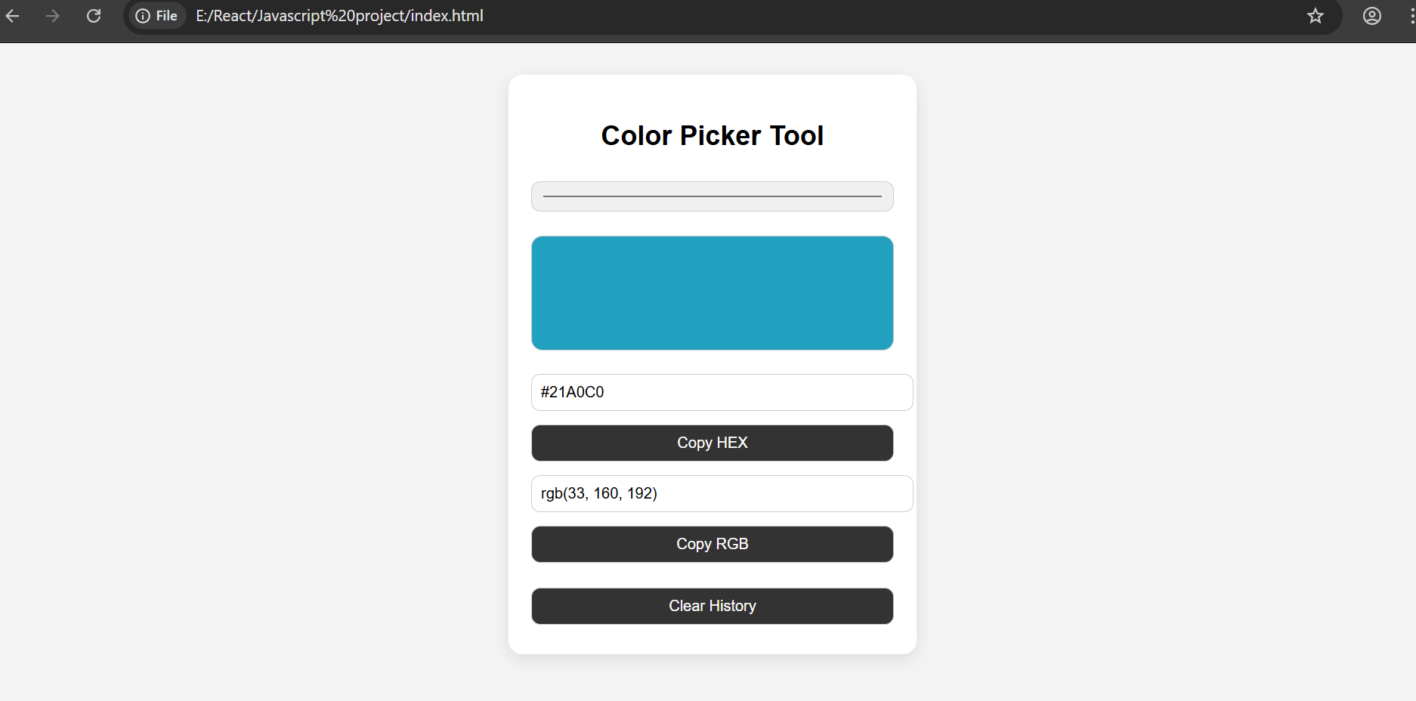
CHAPTER 5: CONCLUSION

The Color Picker Tool was successfully developed using HTML, CSS, and JavaScript. It meets all functional requirements such as real-time color selection, format conversion, and user interaction features.
The project helped in understanding DOM manipulation, event handling, and UI design principles.

CHAPTER 6: REFERENCES

- W3Schools – JavaScript & HTML
- MDN Web Docs
- JavaScript.info
- CSS Tricks
Annexure – III Teacher Evaluation Sheet

Name of Student: Mo Abrar Shoukatx` Shaikh Enrollment No.: 24210940248
Name of Program: Computer Engineering Semester: CO-6K
Course Title: Client-Side Scripting (CSS)
Code: 316005
Title of the Micro-Project: Color Picker Tool
Course Outcomes Achieved: Understand how entrepreneurs pitch ideas, how investors evaluate businesses, and gain insights into funding, negotiation, and startup strategies.
Evaluation as per suggested Rubric for Assessment of Micro-Project
(Please tick in appropriate cell for each characteristic)
Sr.  No. | Characteristic to be assessed | Poor | Average | Good | Excellent
1 | Relevance to the Course Curriculum
2 | Literature Review and Information Collection
3 | Clarity of Project Proposal and Planning
4 | Achievement of Objectives as per Proposal
5 | Analysis of Data and Output Representation
6 | Quality and Functionality of Prototype / Application
7 | Report Writing and Documentation
8 | Level of Understanding during Viva / Oral Examination

Micro-Project Evaluation Sheet

Process assessment |  | Product assessment |  | Total Marks 25
Part A Project Proposal  ( 5 marks ) | Project Methodology (5 marks ) | Part B Project Report / Working Model  (5 marks ) | Individual Presentation / Viva  ( 10 marks)

Comments / suggestion about teamwork / leadership / inter-personal communication (if any):

Any other Comment:

Name and designation of faculty member:

Signature:

